SDITO Lab PC-CS6G4

Name: Debatwik Santra Roll No: CSE/23/110 Exam Roll No.11600223047

Assignment 13
Problem Statement : Create a workmail for your profile.

Solution:
- Sign-in to your AWS console.
- Change your region to N.Virginia from the dropdown on the left-side of the username in the top bar of the console homepage.
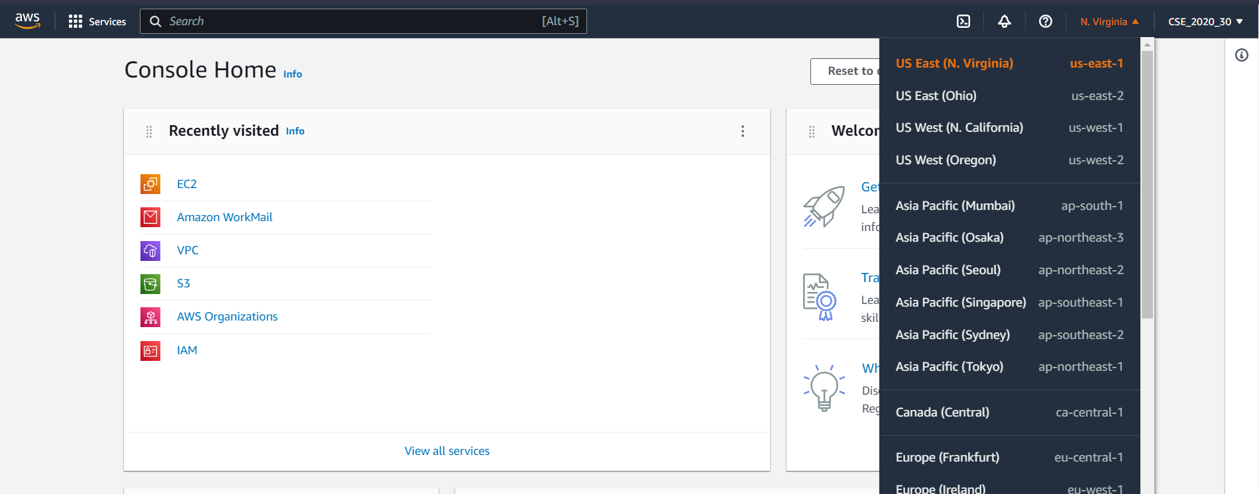
- Search for workmail.
- Select the AWS workmail option.
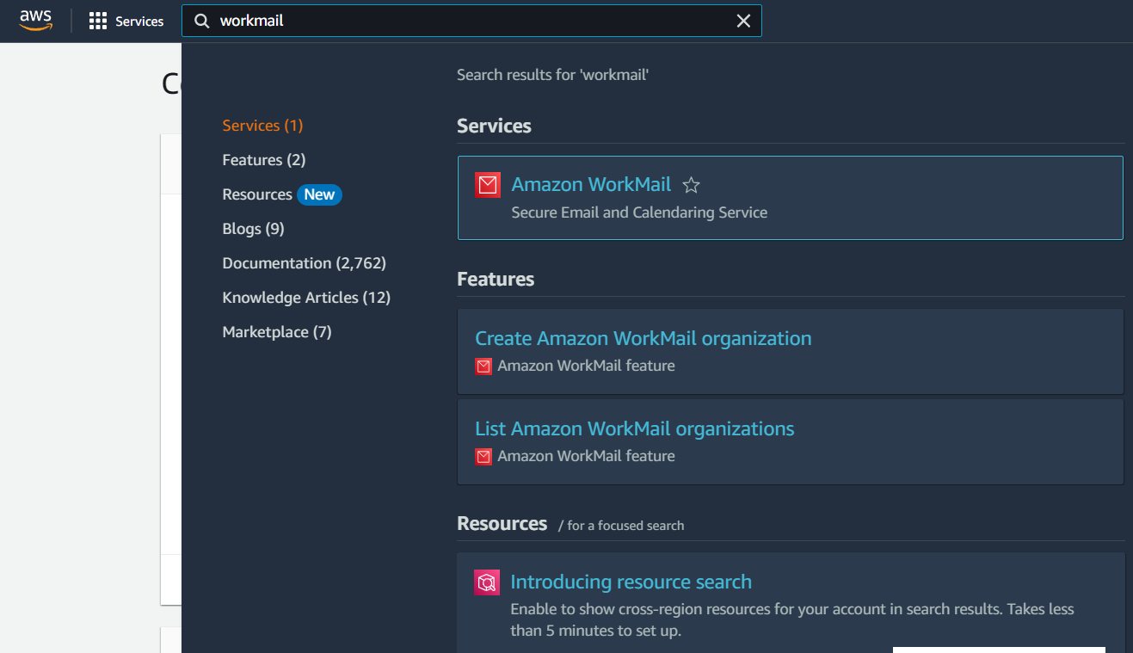
- Click on the create organization button.
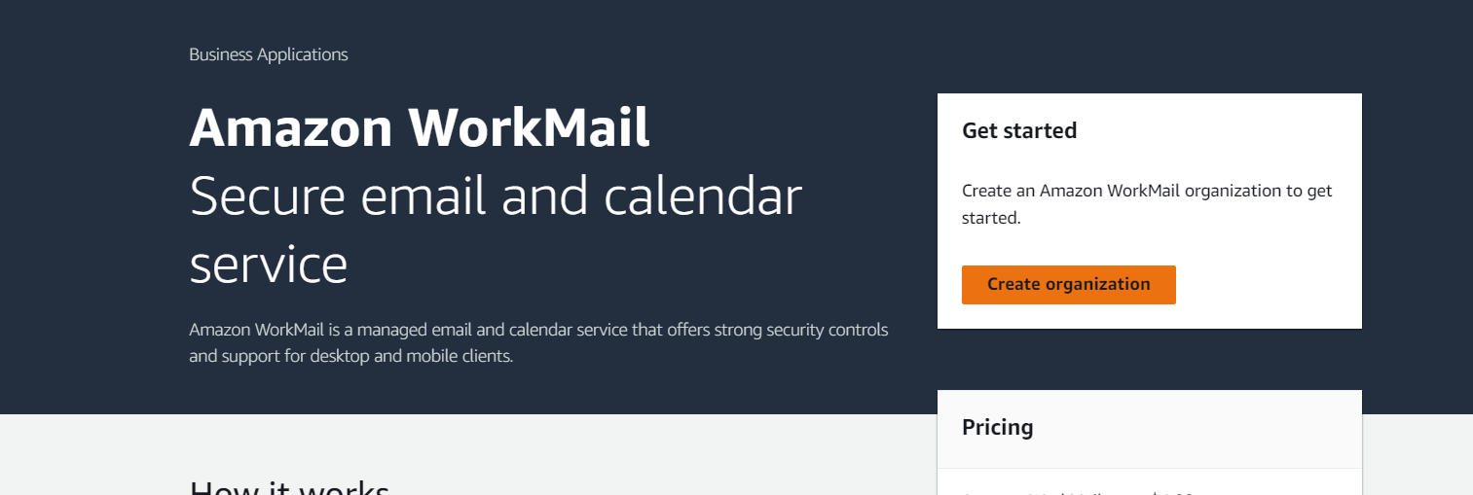

- Select the free test domain option under email domain.
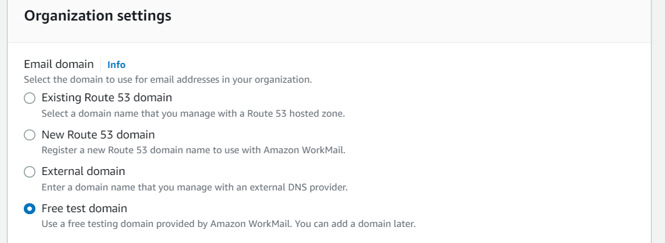
- Give the organization name/ alias. Make sure it is unique in the region.
- Next click on create organization button.
- Wait for two minutes.
- After waiting the organization will become active. Now click on the organization name.
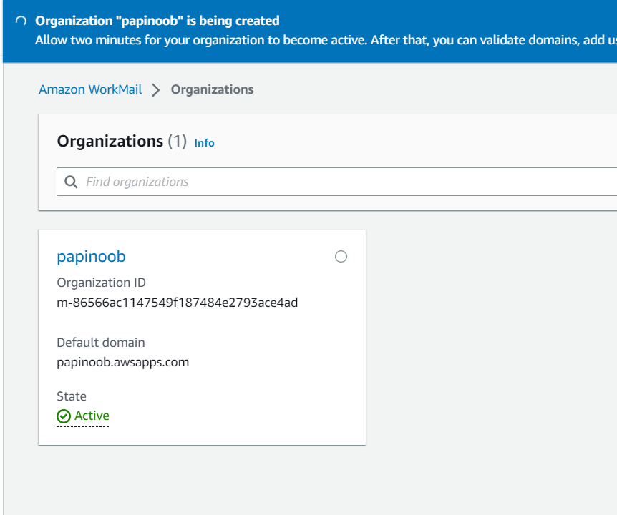
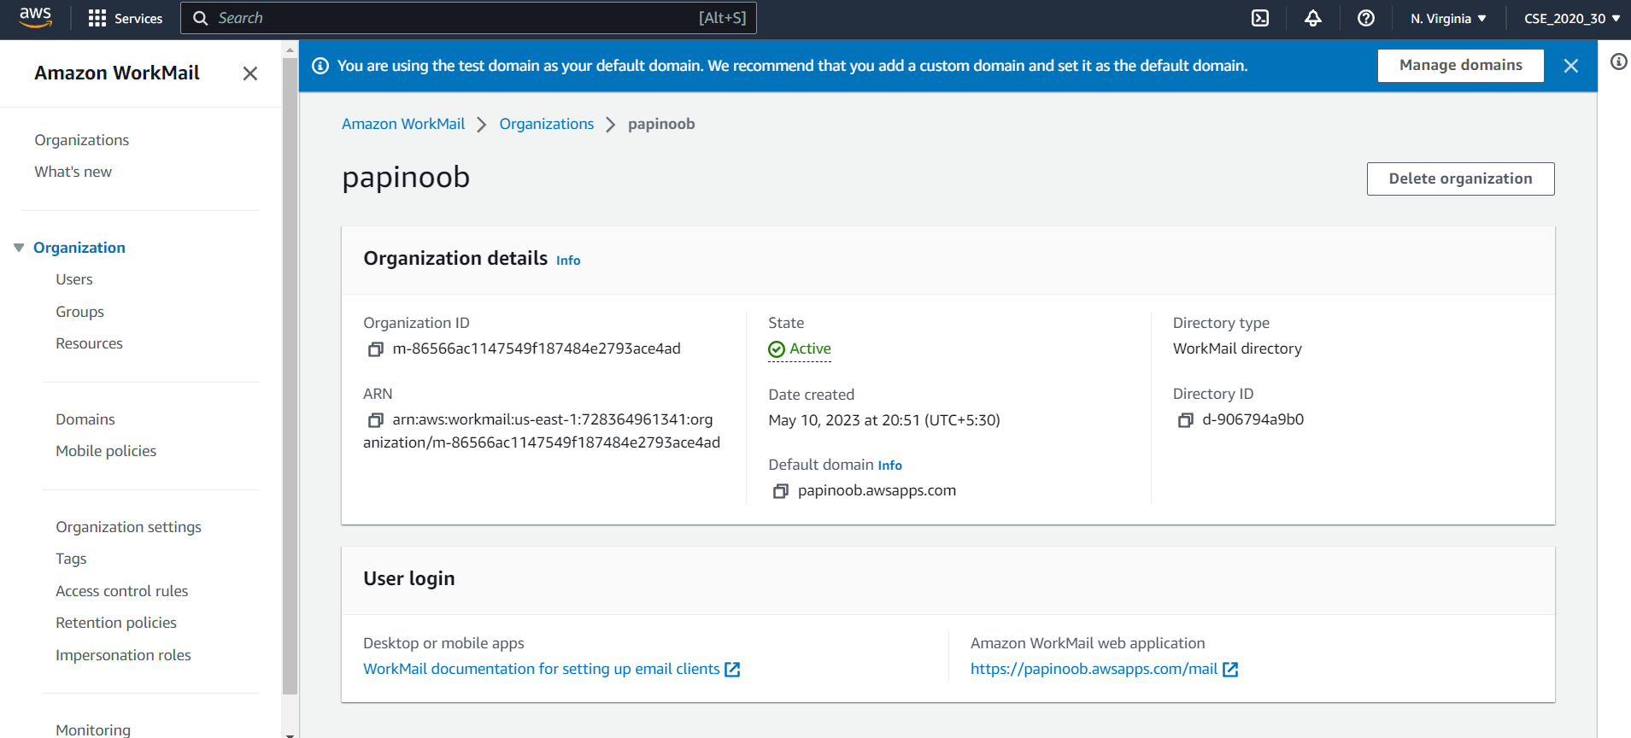
- Now go to the Users section under Organization tab on the left side nav bar.
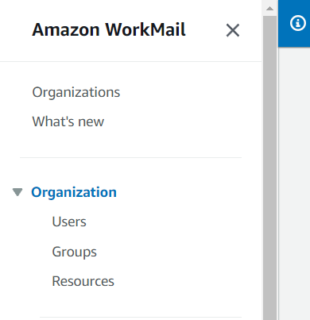
- Click on the create user button.
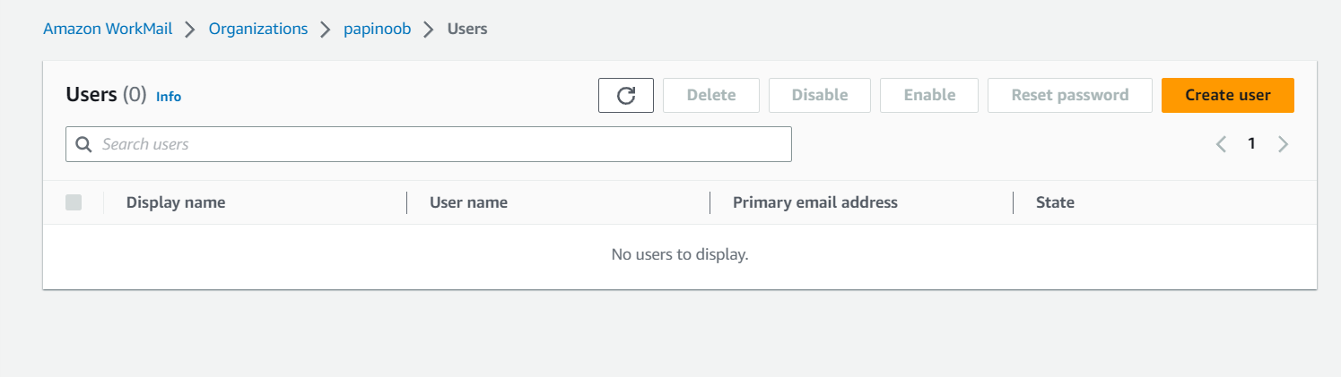
- Give username. Then give a display name.
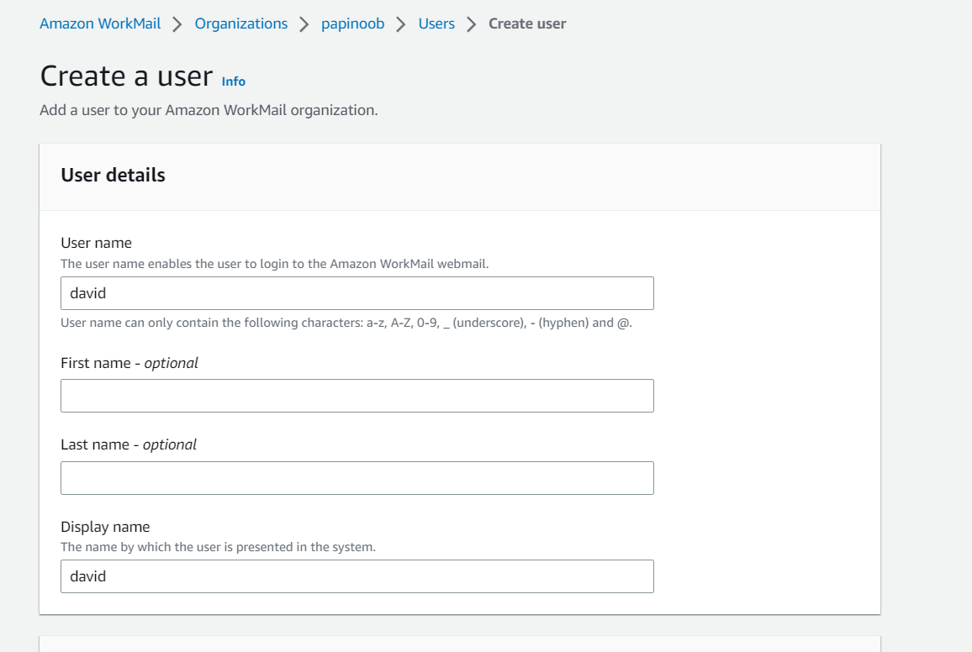
- Then provide the password.
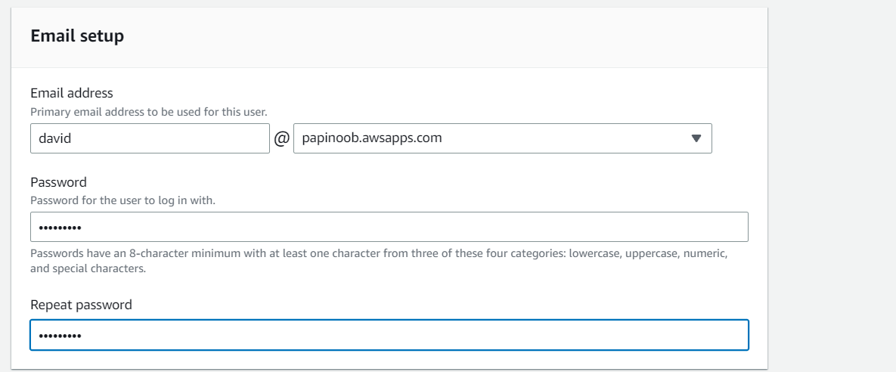
- Next click on the Create User button.
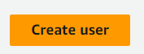
- After the user is created return back to your organization page using the following link.
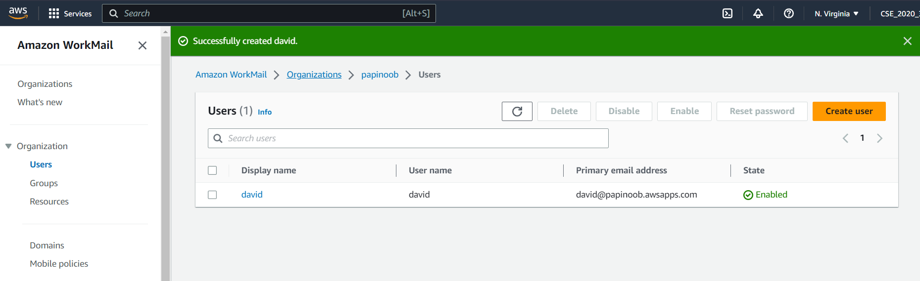
- Click on the organization name.
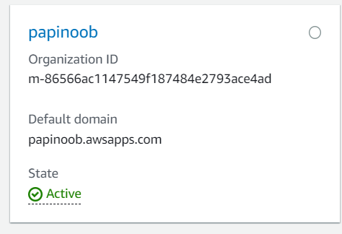
- Now click on the Amazon Workmail web application link.
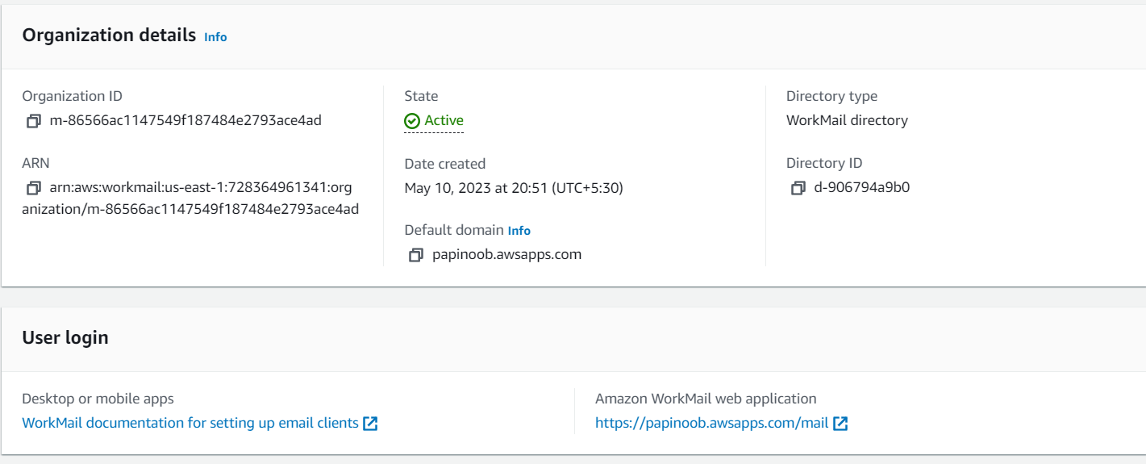
- Enter the credentials of the user you just created in it.
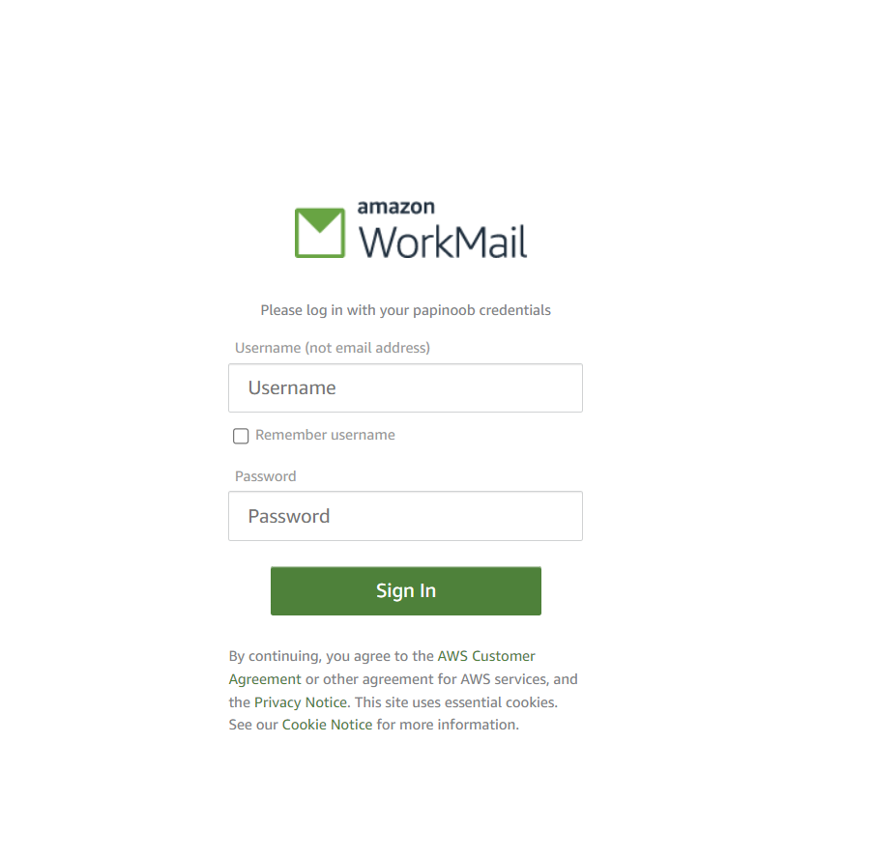
- Our mail will be opened as the entered user.
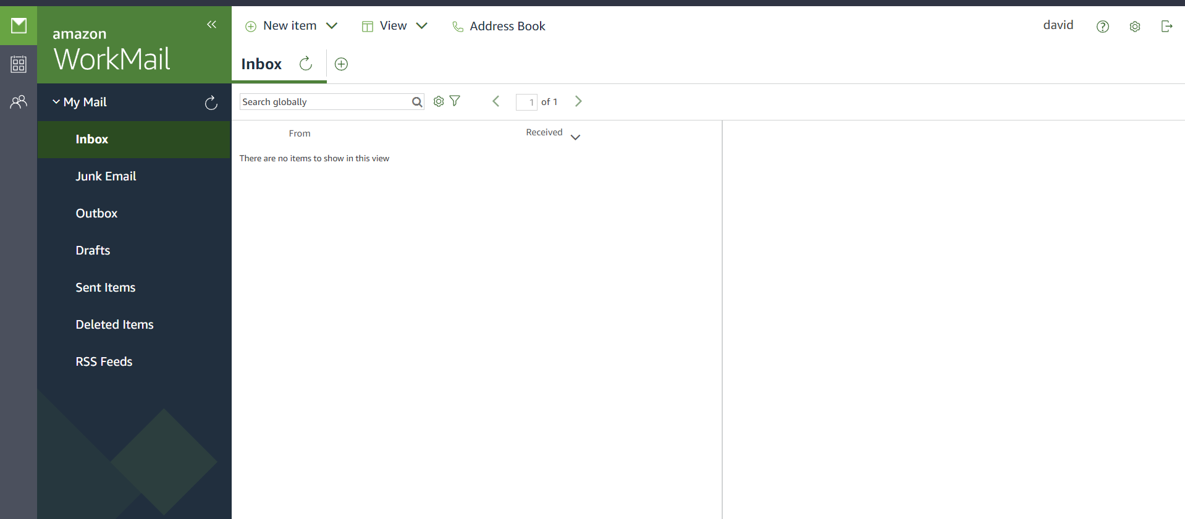

- Now let’s test our mail server by seeing whether it can send and receive mail. Send some mail to your Gmail from this by creating a mail using the new item option.
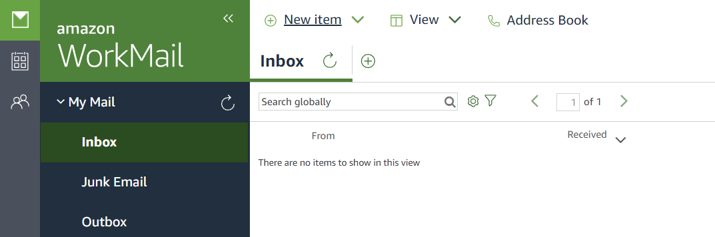
- Select new email. Now write an email to your Gmail address.
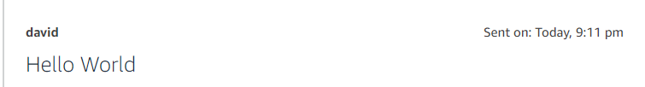

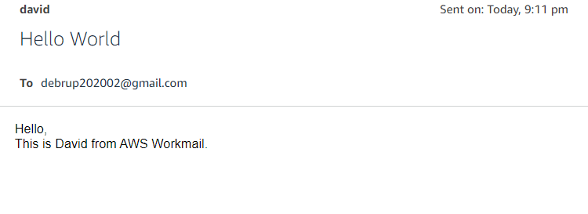
- Check your Gmail.
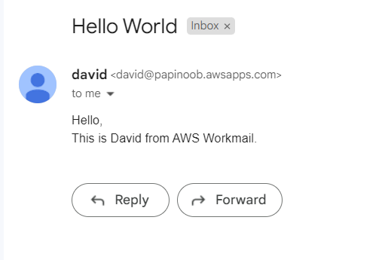
We received it.
- Now send something back to the workmail.
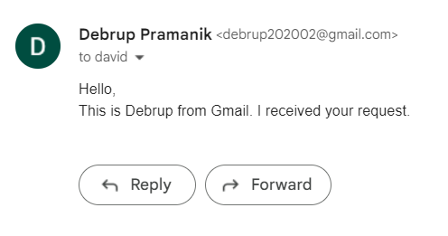
- Check your workmail if you have received the mail. It should be in inbox.
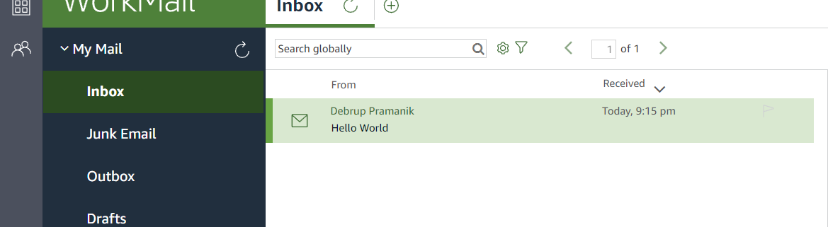
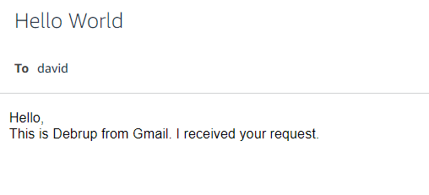
We have successfully received a mail.
Hence our mail is working perfectly fine. We have successfully created a workmail for our profile.

